Name: Vardhan

Email: hvardhanj20@gmail.com

Phone: 647-474-2786

**PROFESSIONAL SUMMARY:**

Having **3 +** years of Experience in DevOps Environment On Linux administration, build engineering and

release management process, building and deploying applications by adopting DevOps practices such

as Continuous development, **Continuous Integration (CI)** and **Continuous Deployment (CD)**in runtime

with various tools like **Git**, **Jenkins**, **Ansible**, **Chef**, **Docker**, **Kubernetes** and managing cloud

services with **Azure** &**AWS**.

Linux/Unix system administrator on Red hat EL, 5.x, 6.x, CentOS 4.x,5.x and VMware environment.

Experienced in administration, troubleshooting, tuning, security, backup, recovery, and upgrades.

Experience on complete software development life cycle (**SDLC**) with software development models like

Agile, Scrum Model, JIRA.

Creating and maintaining Infrastructure for Applications in **AWS using Terraform**. **Building &**

**Automating CICD pipelines** for different applications.

Experience in dealing with **Windows Azure IaaS** - **Virtual Networks**, **Virtual Machines**, **Cloud Services**,

**Resource Groups**, Express Route, VPN, Load Balancing, Application Gateways, Auto-Scaling, and Traffic

Manager.

Worked for 5 scrum teams (Java, AEM, Jenkins, Ant, Maven, SVN, git, Agile methodology, cucumber

scripts, sonar, XL Deploy and XL Release, SharePoint, CI/CD automation from scratch, Docker)

Experience working with monitoring tools like **Splunk**, **Nagios, Prometheus**, **Grafana**, **Cloud watch**, New

**Relic** and **Stack Driver**

Major focus on **Configuration, SCM, Build/Release Management**, **Infrastructure as a code (IAC)** and

as **Azure DevOps** operations Production and cross platform environments.

Experienced in working on **DevOps /Agile** operations process and tools area (Code review, unit test

automation, Build & Release automation Environment, Incident and Change Management) including

various tools.

Worked on deployment automation of all the micro services to pull image from the

private **Docker** registry and deploy to Docker swarm cluster using Ansible.

Integrated Jenkins with various DevOps tools such as **Nexus, SonarQube, Puppet, CA Nolio, HP CDA, HP**

**ALM and HP QTP etc.**

Administrated and monitored activities for **SVN, GIT, TFS, Perforce, UCM Clear case** and **CVS.**

Implemented a complete automated build-release solution using a combination of technologies

like **Maven, TFS, Jenkins**

Developing automated process for code builds and deployments using **Jenkins, Ant, Maven, Sonar type**

**Nexus, Shell Script, Perl, Java.**

Unique experience with Pivotal Cloud Foundry and **OpenShift/Kubernetes** architecture and design,

troubleshooting issues with platform components (**PCF**), and developing global/multi-regional

deployment models and patterns for large scale developments/deployments on Cloud Foundry

and **Open Shift/Kubernetes.**

Used JIRA to keep track of all the ongoing tasks and maintain bug resolutions.

Experience in setting up **CICD** pipeline integrating various tools with Jenkins to build and

run **Terraform** jobs to create infrastructure in **AWS**

Administered and Implemented CI tools **Hudson/Jenkins, Puppet, Chef, Cruise Control, Team City,**

**Octopus** Deploy and **Anthill Pro** for automated builds.

In-depth understanding of the principles and best practices of Software Configuration Management

(**SCM**) processes, which include **compiling, packaging, deploying** and **Application configurations**.

Profusely worked on Version control tools **GIT** , **clear case** to track changes made by different people in

source code involving concepts like **Branching, Merging and Tags.**

Developed and managed cloud VMs with **AWS EC2** command line clients and Services **AWS** provisioning

and worked on services like **EC2, S3, Glacier, ELB** (Load Balancers), **RDS, SNS, SWF** and **EBS.**

**Technical Skills:**

**Operating Systems**

UNIX, Linux, Windows, Solaris

**Cloud Services**

AWS, Azure, Oracle.

**Virtualization Platforms**

**Configuration management**

**CI, Test & Build Systems**

Virtual Box, Vagrant, Xen, VMWare, Oracle VM, Docker, Kubernetes

Chef, Puppet, Ansible

Ant, Maven, Jenkins

**Scripting Languages**

**Languages**

C, C++, XML, Java/J2EE, Python

**Logging & Monitoring Tools**

**Repository Manager**

**Databases**

Splunk, Logstash, Zabbix, Nagios, SonarQube

Nexus, Artifactory

Oracle 10g/11g, Mongo DB, MySQL, MS Access, Redis

Subversion, Git, Perforce, ClearCase

**Version Control Software**

**Professional Experience:**

**Mastercard, Vancouver, BC.**

**Cloud DevOps Engineer**

**April 2021 – Till Date**

**Responsibilities:**

● Worked in highly **collaborative operations** team to streamline the process of implementing security

Confidential Azure cloud environment and introduced best practices for remediation

● Analyzing the landmark of 150 subscriptions for various business cases to apply organization specific

security guidelines

● Gathering the requirements from the clients about the existing applications to apply the **security**

**measures**

● Understand the latest features like (Azure DevOps, OMS, NSG Rules, etc..,) introduced by **Microsoft**

**Azure** and utilized it for existing business applications

● Creating, validating and reviewing solutions and effort estimate of converting existing workloads from

classic to **ARM based Azure Cloud** Environment

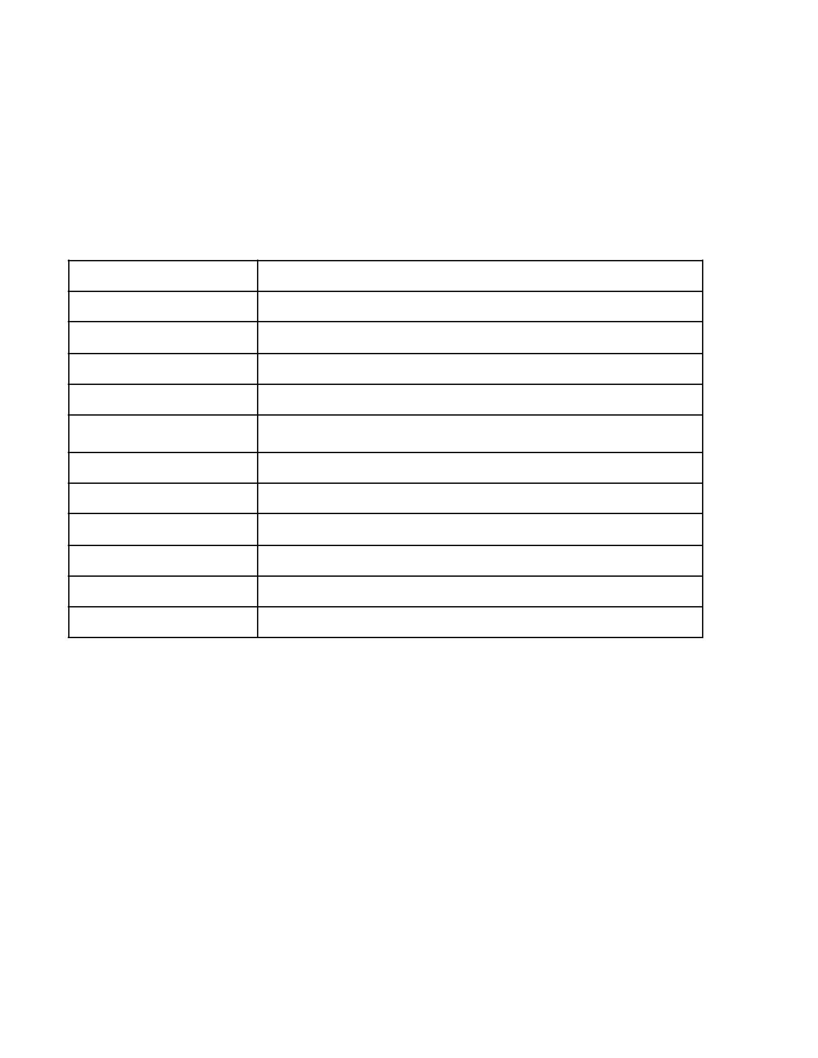

● Developed automation system using **PowerShell scripts** and **JSON** templates to remediate the Azure

services

● Worked on **GIT** to maintain **source code** in Git and GitHub repositories

● Created builds and release pipelines in **VSTS** and done **deployments** using SPN (secure endpoint

connection) for **implementing CI/CD.**

● Implemented automation for deployments by using **YAML scripts** for massive builds and releases

● Created **LTA (Logical Technical Architecture)** diagrams using Microsoft Visio

● Used tools like Visual Studio Community Edition, Visual Studio Code, Power Shell ISE and SQL Server

Management Studio.

● Worked with Agile methodology in **XL Deploy and XL Release**, CI/CD automation from scratch, Docker,

OpenShift)

● Built and Implemented complete CI stack to migrate from a Puppet stack in a colo to **Terraform with Chef**

in **AWS.**

● Wrote shell scripts to handle server processing migrating applications from .Net to Python monitoring

applications and server performance with **Splunk and Jenkins.**

● Worked on Jenkins to implement Continuous Integration and **deployment into Tomcat /Web Logic**

Application Server.

● Had done POC on implementation of continuous deployment pipeline with Jenkins and Jenkins workflow

on Kubernetes

● Assist with configuration of Cloud Compute systems using OpenStack on Ubuntu, collaboration using

Orchestration with Keystone, Kubernetes and other functions within Open Stack.

● Responsible for Configuring Kafka Consumer and Producer metrics to visualize the Kafka System

performance and monitoring

● Worked for 5 scrum teams (Java, AEM, Jenkins, Ant, Maven, SVN, git, Agile methodology, cucumber

**scripts, sonar, XL Deploy and XL Release, SharePoint, CI/CD automation from scratch, Docker)**

● Conducted Dry-Run Tests to ensure fool-proof execution of customized scripts before execution in

production environments.

● Experienced in building, deploying and integrating Java-based web applications in a UNIX, including

exposure to **J2EE/.NET architecture** (especially BEA Web Logic, Tomcat and WebSphere).

● Deploy **Splunk systems** and monitor internal logs from the monitoring Console, troubleshoot existing or

potential issues and resolve the issues.

● Over saw the quality of Automated Build plans to help the Delivery process to NON-PROD and PROD

Environments

● Worked on implementing backup methodologies by **Power Shell** Scripts for Azure Services like Azure SQL

Database, Key Vault, Storage blobs, App Services etc.

● Configured the XL Deploy and XL Release for all the applications from scratch, once the build package is

available, then promoted with simple enable options to **deploy** in the targeted servers.

● Acted as build and release engineer, deployed the services by VSTS (Azure DevOps) pipeline. Created and

**Maintained pipelines** to manage the IAC for all the applications

● Assigned RBAC policies Confidential group level and user level as per the LTA created for the services

implemented new (Automation account, scheduler, notification hub, IOT Hubs, Batch and other services)

● Wrote power shell scripts to create the parameter files automatically for all the services in **Azure**

**Resource Manager**

● Assigned RBAC Roles using **Organization** Active Directory Confidential the Subscription Level to grant

accesses only to required members based on Least-Access Privileges (we use CWS Groups)

● Collaborated with cross functional teams (**firewall team**, data base team, application team) in execution

of this project.

**Environment:** .Net, Azure, PowerShell, XL Release, XL Deploy, Kubernetes, Kafka, GIT, Python, AWS, Splunk,

VMware, Jenkins, Terraform, Ansible, SVN, Puppet, Open Stack, Docker, Jira, Maven, VSTS, Apache

Tomcat Application Server, Salt stack.



**Mitel networks, Toronto, ON.**

**AWS/DevOps Engineer**

**Sep 2019 – Mar 2021**

**Responsibilities:**

● DevOps Workflow representing all stages starting from **SCM Commit** Build, Integration Build Which

Compiles Code, **Junit Test cases** and Code Coverage, Build and Bundle, Publish with Lead Approvals and

Deployment of Artifacts.

● Create and configure Jenkins server using **Terraform and Ansible.**

● Create indexes, forwarder and indexer management, Splunk Field Extractor, Search head Clustering,

Indexer clustering, automation **scripts** save old data into **AWS Glacier**

● Use of Docker, Kubernetes and Open Shift to manage micro services for **development** of continuous

**integration and continuous delivery**

● Launching AmazonEC2 Cloud Instances using Amazon Web Services (Linux/ Ubuntu/RHEL) and

Configuring launched instances with respect to specific applications.

● Installed application on **AWS EC2 instances** and configured the storage on **S3 buckets.**

● Managed IAM policies, providing access to different AWS resources, design and refine the workflows

used to grant access.

● Worked with **git** to **maintain code,** deploy code through Travis and Terraform to Amazon Web Services

via Dies.

● Integrated with Team City and Octopus for the continuous integration and continuous delivery. The

development is incremental, once the changes are checked-in to TFS, the daily build runs, executes the

unit test cases and deploys the changes on CI environment.

● Enhanced existing automated Build/Deploy process and architect the next generation centralized

**deployment** processes using **Octopus.**

● Provisioned EC2 instances, configured auto scaling and defining cloud formation JSON templates using

Ansible modules.

● Administrated and Implemented TFS, Maintained and Migrated TFS&TFS 2012\2013 support.

● Implemented Branching and Merging concepts TFS 2012 and GIT.

● Accomplished tasks of client SCM team and worked on the migration of existing code repository from

ClearCase multisite to TFS.

● Defined application servers on WebLogic Server, created nodes and horizontal created clusters,

configured **Oracle** JDBC provider to provide connectivity via data source to the application.

● Worked extensively on cross-platforms (Windows and UNIX) with **TFS and GIT.**

● Deployed and managed web applications and services into AWS by using Elastic Bean Stalk.

● Managed servers on the **Amazon Web Services (AWS**) platform instances using Puppet, Chef

Configuration management.

● Designed AWS Cloud Formation templates to create custom sized VPC, subnets, NAT to ensure successful

deployment of **Web applications** and database templates.

● Created Maven POMs to automate the build process for the new projects and integrated them with third

party tools like SonarQube, Nexus.

● Created Bus members, provided configurations for messaging queue in **WebLogic.**

● Deployed and designed pipelines through Azure data factory and debugged the process for errors.

● Involved in creation of virtual machines and infrastructure in the **Azure Cloud environment.**

● Created Chef **Automation tools** and builds and do an overall process improvement to any manual

processes.

● Worked on developing the backend part of the application involving Spring 3, JPA and Hibernate

● Implemented unit **testing framework** driven using Junit and Cucumber.

**Environment:** Amazon Web Services (AWS), Azure, Octopus, IAM, S3, EC2,VPC, cloud watch, Nix, Azure, ANT,

Maven, Tortoise SVN, GitHub, Chef, Puppet, Ansible, Terraform, Docker, WebLogic, Splunk, SonarQube.



**OpenText, Toronto, ON**

**System Administrator**

**July 2018 - Aug 2019.**

**Responsibilities:**

●

●

●

●

●

Responsible for building out and improving the reliability and performance of cloud applications and

**Cloud infrastructure** deployed on Amazon Web Services.

Developed environments of different applications on AWS by provisioning on EC2 instances using

**Docker, Bash and Terraform.**

Writing Ansible Playbooks with Python SSH as the Wrapper to Manage Configurations of AWS Nodes

and test Playbooks on AWS instances using **Python.**

Designed AWS CFTs to create custom sized VPC, subnets, NAT to ensure **successful deployment** of Web

applications and database templates.

Built S3 buckets and managed policies for S3 buckets and Created users and **groups using IAM** and

assigned individual policies to each group.

●

●

●

●

●

●

●

●

●

●

●

Created business specific VPCs, and Security Gateways and AWS Security groups to enable firewall.

Installed, configured and upgraded **Ubuntu 12.04 to 14.04** using customized Kickstart

Installed and maintained **Red Hat 6.x and Centos 7.x**

Maintaining **backup** drive

Provided application support for software running on **Unix** and **Ubuntu**

Provided IT support for internal resources and services for the whole team

Used **SVN** tool for version control

Wrote BASH script for automation

Installed and configured Apache **Tomcat & Jboss**

Installed and configured **SSL certs**

Developed branching strategy within GitHub and created a release version of the application which is

deployable to hosted environments including production.

●

●

Worked on Groovy scripting to automate and maintain the deploy jobs and application config to

different environments.

Implemented **AWS Code** Pipeline and created **CFT JSON** templates in **Terraform** for infrastructure as

code.

●

●

●

Created functions and assigned roles in AWS Lambda to run python scripts.

Created Lambda jobs and configured Roles using **AWS CLI.**

Implemented **PagerDuty** alerting system in the event of service failure and improved the application

availability to end users.

●

●

●

●

Implemented and maintained the monitoring and alerting of production and corporate servers/storage

using Cloud Watch.

Deployed cloud stack using AWS Ops Works, Optimized volumes and **EC2 instances** & Created multi AZ

**VPC instances.**

Installed and implemented Ansible configuration management system to manage web applications,

environments configuration files and users.

Worked with **Selenium** and integrated into the pipeline and thereby improved resource utilization and

capture performance of the application.

**Environment**: AWS services, IAM, VPC, GitHub, PagerDuty, Groovy, Splunk, Ansible, Security Groups,

Lambda, Selenium, Grafana, SVN, GIT, Jenkins, Maven, Nexus, WebLogic, Python Scripts, XML, Bash

scripting, Unix, JIRA.

